|  |  |  |  |  |  |  |  |
| --- | --- | --- | --- | --- | --- | --- | --- |
| Submission Coversheet | | | |  |  |  |  |
|  |  |  |  |  |  |  |  |
| **Student ID Number** | ANI18457381 | | | | | | |
| **Programme Title** | Computing Technologies Degree | | | | | | |
| **Module Title** | Web Development | | | | | | |
| **Module Code** (listed on Moodle and in LTAFP) | [QAC020C153A](https://partnerships.moodle.roehampton.ac.uk/course/view.php?id=489) | | | | | | |
| **Module Convenor** | Ekereuke Udoh | | | | | | |
| **Coursework Title** | Coursework2: JS Wedding Planners - Reflection | | | | | | |
| **Academic Declaration:**  Students are reminded that the electronic copy of their essay may be checked, at any point during their degree, with Turnitin or other plagiarism detection software for plagiarised material. | | | | | | | |
| **Word Count** | 1438 | | | **Date Submitted** | | **16/12/2018** | |
|  |  | | |  | |  | |

Table of Contents

Goal Achievement 3

Research 3

Site Usability and Accessibility 4

Further Enhancements 8

# Goal Achievement

The website JS Wedding Planners is composed out of five pages: Home, Portfolio, Packages, Services, Contact, and it uses pictures and tables all over the project. The system for receiving customers data was implemented on the Contact Page along with contact details, a video and a map which portray the location of the company.

The tests were done continuously with the implementation on several browsers like Microsoft’s Edge, Apple’s Safari, Chrome, Firefox, Opera and the T-Rex of web clients, the one and only Internet Explorer.

Deployment was done firstly locally with the open source server package XAMPP, and after that I hosted the project on the Hostinger web servers for a complete development experience.

# Research

To be honest about this, my first research action was to check other related wedding sites. I tried as much as I could to not copy their ideas, and because of this my home page took a very long time to complete, with two failed attempts to finish it. The search helped me a lot in structuring the pages and their content by creating a portfolio page for presenting the companies best photos, and a packages page to show detailed tariffs. The home, services and contact pages were indirectly implied by the projects deliverables.

As I mentioned earlier I changed my mind a lot regarding the first page, part of it because I couldn’t find a good structure for the page, and because I couldn’t decide on a color palette schematic. My solution was to browse through the custom colors creator in Microsoft’s Paint and hand search for them. This is how I found the two related colors for the background and content shown in Figure 1.

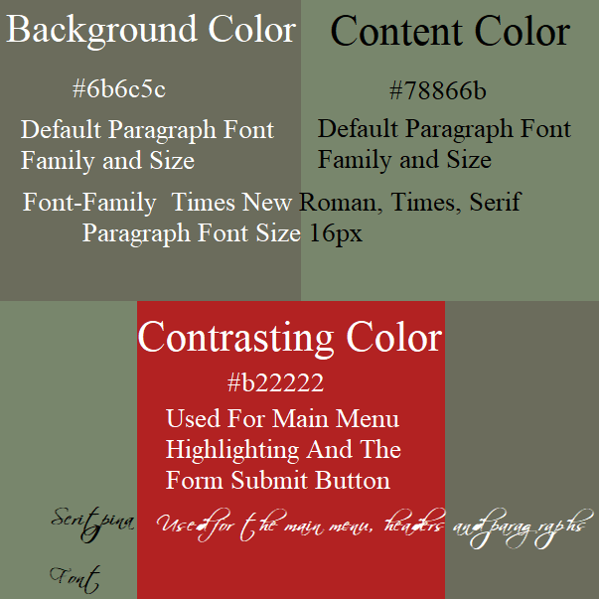

Figure 1

For the contrasting color I just cycled through the listed colors in the Adobe Brackets auto-complete options and settled for firebrick. Now these colors are not considered web safe according to Encycolorpedia. 2018. Hex Colors, Color Picker, Schemes, Paint Search & Conversions. [ONLINE] Available at: <https://encycolorpedia.com/>. [Accessed 8 December 2018] and I tried to change them in the last days before the dead-line, but nothing really clicked and left them as they were.

For the text I already had in my mind that I would use a handwritten font for the menu and for the headers and a regular font for the paragraphs. The problem was that I couldn’t find any standard handwritten fonts compatible with all the browsers. Because of this I searched for a free font to store it locally and found scriptina-font. This wasn’t the best choice I’ve ever done because it was hard to handle due to some overlapping character issues and because it was hard to read when zooming out in the browser. Therefore, I was constrained to set the font size of scriptina-font to higher values for a better usability and accessibility experience.

A new technique I used extensively beside the known ones was CSS Grid Layout. To master this new approach, I had to watch a dozen of videos on YouTube and a lot of trial and error implementation attempts. The Achilles Heel of this technique is that it has a browser compatibility coverage of about 88%, see Figure 3, according to Can I use. 2018. Can I use... Support tables for HTML5, CSS3, etc. [ONLINE] Available at: <https://caniuse.com/#search=grids>. [Accessed 29 November 2018]. This is due to backward compatibility and Microsoft’s Internet Explorer plus other browsers which still don’t support CSS Grids. Even though the browser coverage is not high, this was a chance I took because it is easy to use, and my design idea matched with its current features.

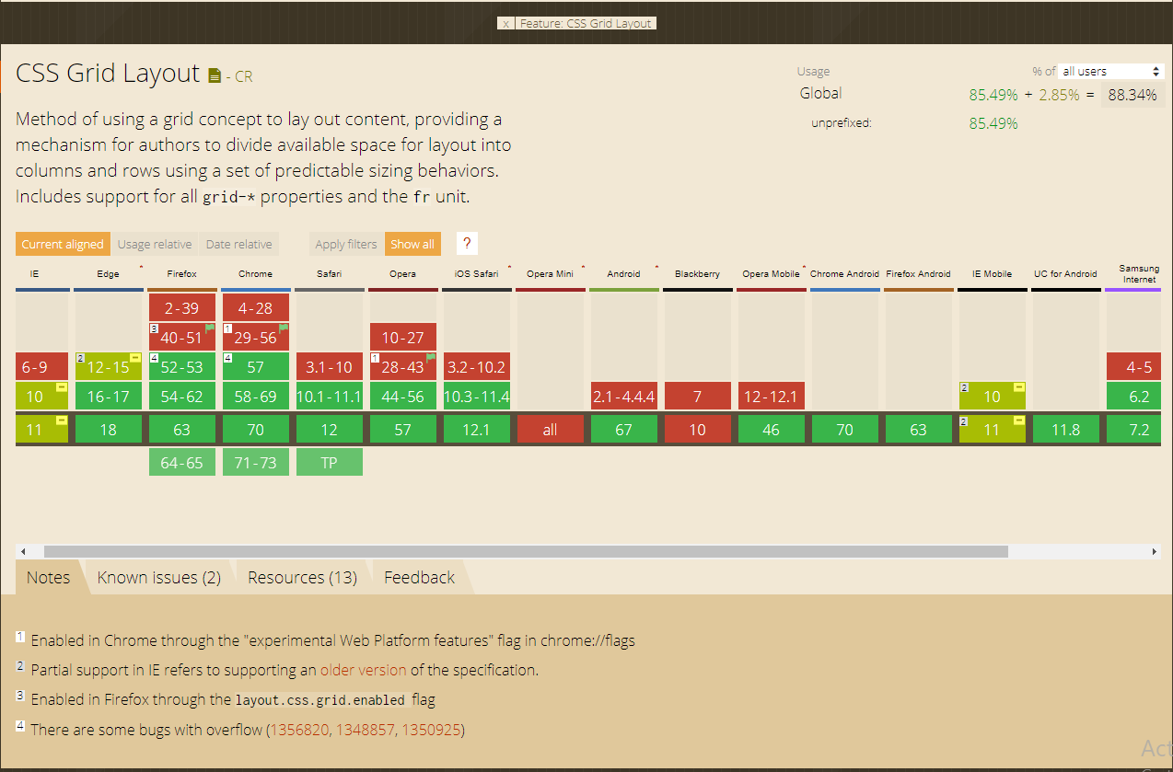

Figure 2

For device display responsiveness I’ve used a very good e-book by Frain, B., 2015. Responsive Web Design with HTML5 and CSS3 Second Edition. 2nd ed. Livery Place 35 Livery Street Birmingham B3 2PB, UK.: Packt Publishing Ltd, which in my defense I just utilized it for fast searching of solutions for my issues due to the lack of time. Nevertheless, it helped me a lot in introducing me to media queries and meta tags, flexbox, custom fonts, video, forms and validation.

# Site Usability and Accessibility

Accessibility mainly focuses on users who struggle with disabilities and usability improves efficiency, effectiveness and satisfiability of the web-site. Even though web accessibility seems different from web-site usability it also improves user experience overall being considered a prerequisite according to Web Accessibility Initiative. 2010. https://www.w3.org/WAI/intro/usable. [ ONLINE ] Available at: <https://www.w3.org/WAI/intro/usable>. [Accessed 29 November 2018].

The usability of this site is given by its simplicity and concise information, with no flashy presentations and one click away reachability of any page. Another strong point for the projects usability is that beside the responsive main menu, the web site has a secondary method to reach the pages with the help of the left and right buttons on the top of the page. The left/right buttons have a background image which represents a minimized version of the neighboring page so that the user realizes what page it accesses. These two buttons are a major usability plus on smaller devices, because of their responsive ability, by increasing their size depending on the type of the device. For example, a mobile device will have the buttons a lot bigger than a desktop computer for a better experience and ease of use.



Figure 3

Another menu related usability improvement as presented in Figure 4 is the transformation of the main menu from the horizontal positioning on the wide resolutions to vertical positioning on mobile devices with a toggle button to show it or hide it. As a bonus I introduced a visual highlighting of the toggle button on mobile devices to show the current position of the page by contrasting one of the five lines inside the button, referencing to its page location.

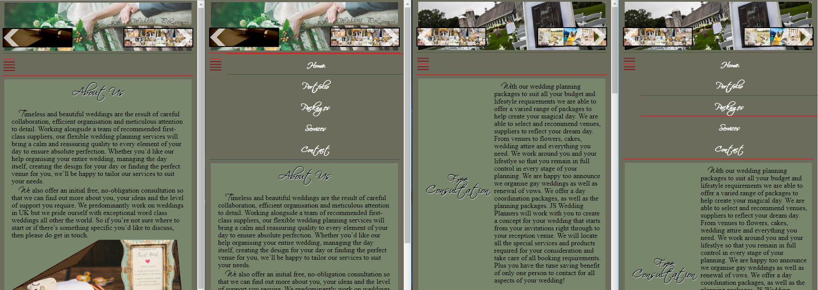

Figure 4

On the other hand, a major drawback on the usability part of the site is that the image resources weren’t carefully sorted and converted for the needs of the project. This optimization is fundamental for a satisfactory user experience according to the Ilya Grigorik. 2018. Image Optimization | Web Fundamentals | Google Developers. [ONLINE] Available at: <https://developers.google.com/web/fundamentals/performance/optimizing-content-efficiency/image-optimization>. [Accessed 9 December 2018].

Other usability improvements worthy to mention are:

* Form validation for every input according to its type and needs, see Figure 5
* Back to top button visible only when scrolling down in the bottom part of the page, see Figure 5

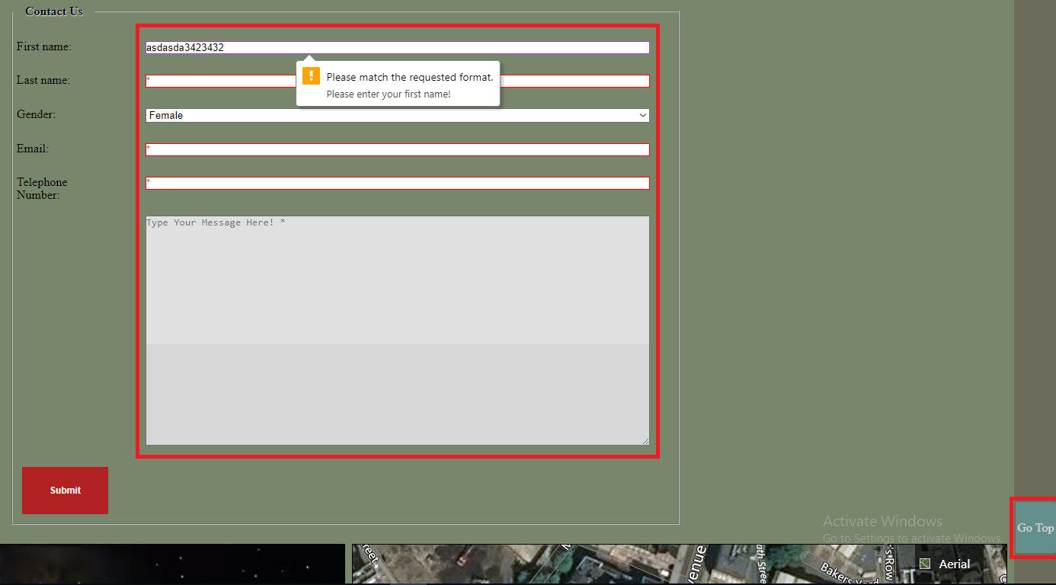

Figure 5

Some of the techniques used for enhancing site accessibility are:

* Every page has the language tag set to English
* Images, inputs and menu items have the title and alternative property set with a detailed text;
* The text size is set with at least 16 pixels
* As shown in Figure 5 the contrast between text and background color is within the WCAG 2 level AA standard according to the tests done on the WAVE. 2001. WAVE Web Accessibility Tool. [ONLINE] Available at: <http://wave.webaim.org/>. [Accessed 1 December 2018].

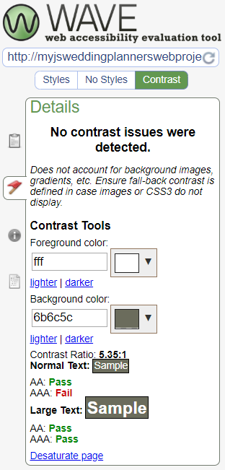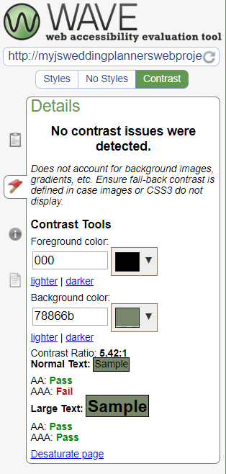

Figure 6

* The headings have been nested accordingly to their rank
* Page division is marked up semantically by the Html5 tags: main, nav, sections, figures, articles lists and so on

Even though I thought the improvements enumerated above are sufficient for a simple site, according to the Web Content Accessibility Guidelines (WCAG). 2008. Web Content Accessibility Guidelines (WCAG) Overview | Web Accessibility Initiative (WAI) | W3C. [ONLINE] Available at: <https://www.w3.org/WAI/standards-guidelines/wcag/>. [Accessed 8 December 2018] the web project is far from achieving 100% WCAG 2 standardization.

# Further Enhancements

List of future improvements:

* Align the project to the WCAG 2.1 accessibility standards
* Implement RESTful API for storing the form information in a database
* Change the pallet schematic to web-safe colors
* Divide the Services page into sub pages
* Resolve the Microsoft Explorer browser family compatibility issues
* Move the script code from the html files to java-script files
* Move the Bing Map requests and code on the server side, and make a custom post request, this is good for hiding the credentials and for simulating the response in case the service is down.
* Implement a login page for admin management of the servers database